# Overview of Virtualization for Distributed Computing as Applied to JHA Xperience

Virtualization provides increased utilization of hardware, server agility and availability by decoupling the various aspects of application delivery to the customer/user. Two racks of servers replace data center aisles of low utilization 1U servers with deployment cut down to days or even hours. The pain of one server, one OS and a range of software that may or may not play well together is solved as many independent servers can take advantage of a single physical machine. For the purposes of this document, the overview will break virtualization into two distinct categories that do not necessarily know or care about the other; they are Infrastructure/server virtualization and session virtualization (application delivery). From a 10,000-foot view, the diagram below illustrates the subject of virtualization and components involved.

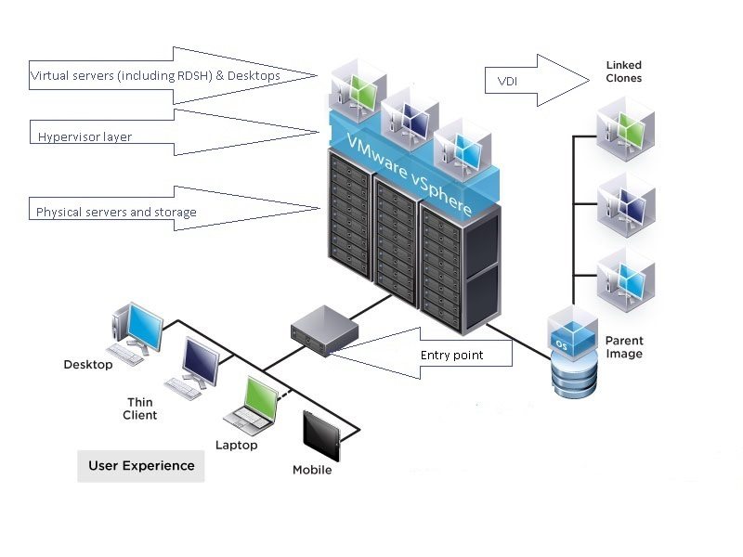

**Section 1: Server or Infrastructure Virtualization**

**Major players:**

1. *VMware’s vSphere (ESXi, vCenter)* - By far the field’s leader, innovates and executes.
2. *Microsoft’s HyperV*- Up and coming but behind in features, security footprint and management.

Niche players worth noting are Citrix’s XenServer, Oracle VM server, Linux KVM.

**Features:**

Combined with a shared storage solution, hypervisors create an array of advantages as listed belowwhich is but a small sample . More in depth features with descriptions can be found here, [VMware hypervisor features](https://pubs.vmware.com/vsphere-50/index.jsp?topic=%2Fcom.vmware.vsphere.introduction.doc_50%2FGUID-A8B8E6DC-A881-4F14-AEC1-D17365731E68.html).

1. Reduced overall footprint- Reduced floor space and the subsequent cascading affect that goes along with it such as lower power consumption, less networking switch ports needed, smaller air conditioners, etc…
2. Agility- By taking advantage of a shared storage solution, virtual machines can live and migrate freely amongst other physical servers in their group. Should host A experience a spike in usage, host B can transparently absorb some of host A’s workload.
3. Faster deployments- Servers are now pooled resources available on demand thus reducing (not eliminating) reliance on the procurement process and other business aspects of corporate life. Driver compatibility issues are removed; server templates can be created once and copied many times with a relatively small effort before becoming an operational server.
4. Reduced vendor lock in- Hardware is a commodity, a virtual machine can migrate from a Dell server to HP to IBM and the OS will never realize it happened.
5. Server Management- Within one client, you can adjust resources like memory and CPU, bring up console sessions, and evacuate all VMs from a single host for maintenance and patching.
6. Operational and Disaster recovery- By utilizing shared storage, backups are now taken at a block level instead of file level making servers portable.

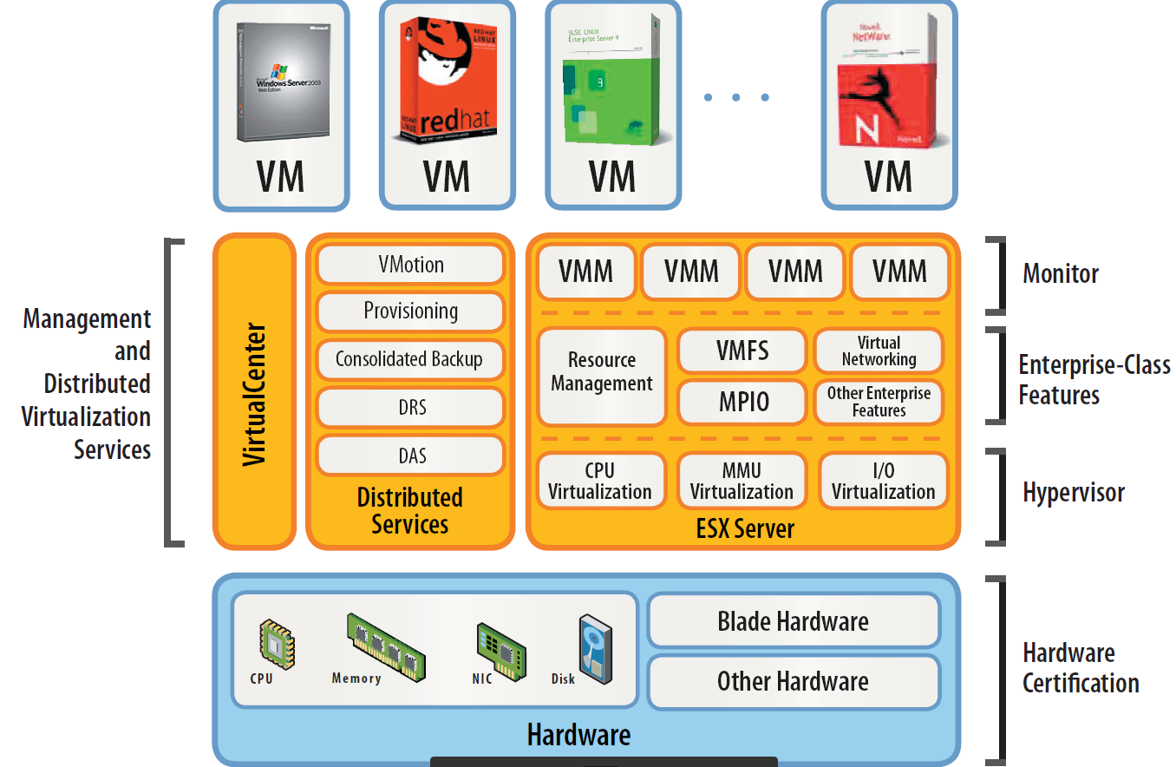

*Illustration provided by Vmware.*

**Section 2: Application Delivery / VDI**

**Major players:**

1. VMware Horizon View
2. Microsoft RemoteApp/RDSH
3. Citrix XenApp/XenDesktop

**Features:**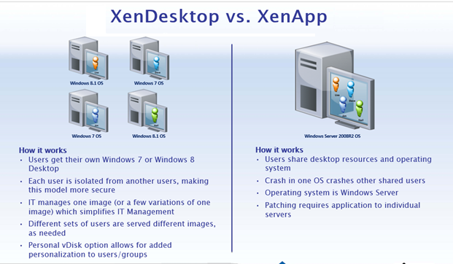

RDSH

VDI

*Illustration provided by Citrix.*

**VDI**- (Products: Citrix XenDesktop; VMware View)

Virtual Desktop Infrastructure (VDI) provides a method of deploying many independent virtual Windows 7 or Window 8 machines sharing resources from VMware hosts directly. These virtual machines are either live clones of golden image or “boot from SAN” to a golden image with all necessary applications installed. The upside to this type of application delivery is that it provides a method of centralizing desktop management and security while allowing business to utilize old PC hardware as thin clients. The downside here is that VDI is VERY resource (disk) intensive and can easily become the most expensive solution when tuning for performance.

**RDSH-** (Products: Microsoft RDS; Citrix XenApp, VMWare Horizon)

Remote Desktop Services Host (RDSH) is a general umbrella term when referring to products like Citrix XenApp, VMware Horizon and Microsoft RDS because all three products are based on Microsoft RDS (depicted on the right side of the illustration above). Very important to note, without Microsoft Windows RDS this method of delivering applications does not exist for any of these products. What differentiates Xenapp and Horizon is protocol efficiency, better management and additional features equating to a better user experience, especially for remote users. Over the last few years, trends have leaned toward VDI but coming back to the RDSH model due largely to storage costs.

**Section 3: Performance forecasting**

Performance forecasting is far from an exact science and has many variables that need to be taken into account. Factors such as:

1. Server hardware; BUS speed, memory, CPU, performance of shared disk all play a major role.
2. Hyperthreading is enabled on the processor.
3. Server farms being administered to best practice standards.
4. VM right-sizing; both under **&** over provisioning a VM have negetive effects.
5. How do VM administrators segregate work load and follow best practice in that regard? For example, CPU overcommittment is common for “normal” workloads in VMware but can be an issue with RDSH workloads.
6. End user experience factors; are they using VDI or RDSH.
7. Application consumption; there are light, medium and intensive applications all running on the same server. In that token the same can be said for various user’s productivity.

Based on performance analysis we have completed, client discussions and VMware’s research on common applications we can ball park the recommendations below. These should not be taken as hard rules, we have only completed two analysis sessions to date so the sample size is **FAR** from comforting. On the bright side, the utilization metrics we have for common apps (MS Word, Excel, Lotus notes, etc…) has matched VMware’s findings leading us to believe we are taking the correct approach.

Xperience analysis and calculations based on the following executables running concurrently:

* JackHenry.Xperience.ClientAgentMonitor.exe
* JH.SynapsysXP.App.Desktop.exe
* jhaintexec.exe
* jw9c.exe
* SilverLake.exe
* SYNDM.exe
* SynergyClient.exe
* Xperience.exe

**VDI recommendation:** Based on the assumption that all best practices are followed, CPU Hyperthreading is enabled and the underlying host is not overcommitted, 2 processors and 4GB of memory should be sufficient to deliver good performance to an Xperience user running a single Xperience application. Each additional Xperience application will require an additional .5 GB of memory.

**RDSH recommendation:** Based on the assumption that all best practices are followed, CPU Hyperthreading is enabled and the underlying host is not overcommitted we believe the recommendations below should be sufficient for delivering good user performance in the Xperience application.

1. 6 users per vCPU for processing. For example, if a XenApp VM has 4 processors you should plan on 24 users or less per XenApp server to stay within CPU requirements.
2. Plan for 1.35GB of memory per user for the first Xperience application alone to deliver good performance. Each additional Xperience application will require an additional .5 GB of memory.